Finite Volume Modelica package for Modelica.Fluid
Hilding Elmqvist, 2004-08-27

Introduction
This memo can be seen as an extension to the paper “Oriented Modeling of Thermo-Fluid Systems” (Elmqvist, et.al., 2003).

Mass-, momentum- and energy-balances
We will show a general implementation of the governing equations, which might serve as a template for specialized models. Consider the equations (mass, momentum and energy balances) for quasi-one-dimensional flow in a device with flow ports in the ends such as a pipe, Thomas (1999), Anderson (1995).
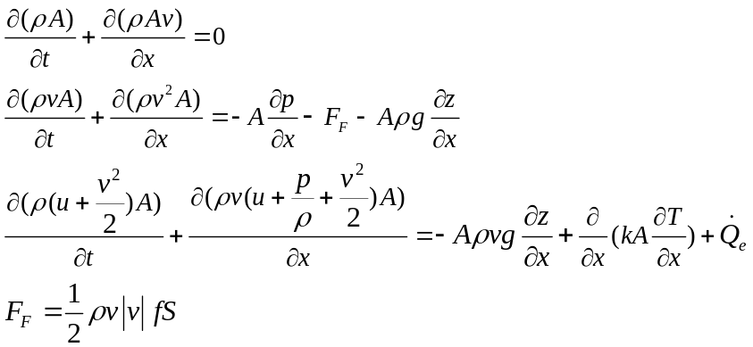
where t represents time, x is the spatial coordinate along device,  is the density, v is the velocity, A is the area, p is the pressure, F_{F} represents the friction force per length, f is the Fanning friction factor, S is the circumference, g is the gravity constant, z is the vertical displacement, k is the thermal conductivity and medium properties:
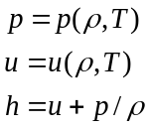
where h is the specific enthalpy and u is the specific internal energy.
The energy equation can be considerably simplified by subtracting the momentum balance multiplied by v. Simplifications that are shown in the appendix, give the result.
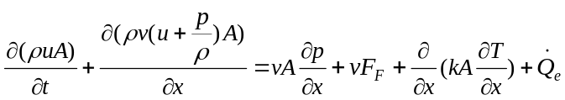

Finite volume method
Such partial differential equations can be solved by various methods like finite difference, finite element or finite volume methods. The finite volume method is chosen because it has good properties with regards to maintaining the conserved quantities. The device is split into segments, for which the PDEs are integrated and approximated by ODEs. Let x=a and x=b be the coordinates for the ends of any such segment, x=r represent the midpoint of such segment.

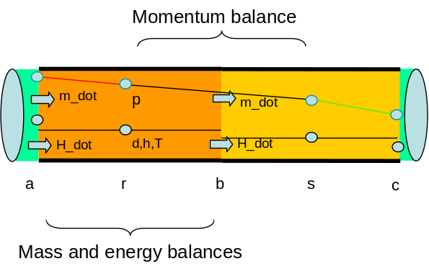

Mass balance

Integrating the mass balance equation over the spatial coordinate, x, between a and b, gives
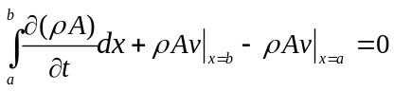
Assuming the segment boundaries (a,b) to be constant, we can interchange the integral and derivative:
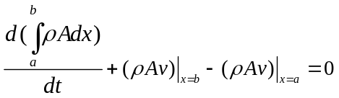
In order to handle the general case of changing volumes for, e.g., displacement pumps, tanks, or moving boundary models of two phase flows, this formula needs to be extended by use of the Leibnitz formula.
Introducing appropriate mean values for density and area, associated with the mid point r, and introducing incoming mass flow rates 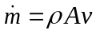, 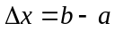, we can rewrite the mass balance as:
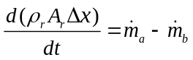
To simplify notation, we use subscripts to denote the x coordinate, i.e. 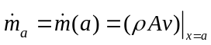

The corresponding Modelica notation could be (area is constant in time):

der(medium.d)*A_m*dx = port_a.m_dot + port_b.m_dot;

or when using spatial domain notation:

der(d(r))*A(r)*dx = m_dot(a) - m_dot(b);

Energy balance
Integrating the energy balance for internal energy over the interval a to b gives:

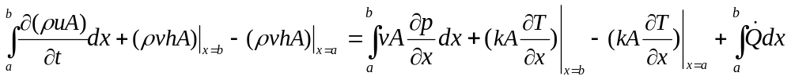
Interchange of integral and derivative, introduction of 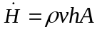, substitution and approximation gives
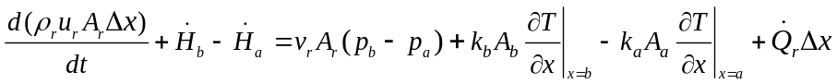
The term 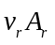is written as 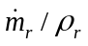.
The Modelica notation for this energy balance is:

der(medium.d*medium.u)*A_m*dx = port_a.H_dot + port_b.H_dot
+ m_dot_middle/medium.d*(port_b.p - port_a.p) + heatPort.Q_dot;

(see below for diffusion term) or when using spatial domain notation:

der(d(r)*u(r))*A(r)*dx = H_dot(a) - H_dot(b)
+ m_dot_middle(r)/d(r)*(p_end(b) - p_end(a))
+ k(b)*A(b)*pder(T, b) - k(a)*A(a)*pder(T, a)
+ Q_dot(r)*dx;

The diffusion term contains the temperature gradients at the segment boundaries. A first order approximation of the gradient is
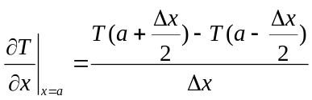
The Modelica function pder(T, a) defines this gradient. Alternatively, it can be added to the H_dot definition.

dT_dx_a = (medium.T - medium_a.T)/dx/2;
dT_dx_b = (medium_b.T - medium.T)/dx/2;

port_a.H_dot = semiLinear(port_a.m_dot, port_a.h, medium.h) + (if
includeThermalConductance then -k*A_a*dT_dx_a else 0)
"Upwind scheme";
port_b.H_dot = semiLinear(port_b.m_dot, port_b.h, medium.h) + (if
includeThermalConductance then k*A_b*dT_dx_b else 0);

Momentum balance
We proceed in a similar way with the momentum balance. However, the integration is performed over the interval r to s with the mid point b:
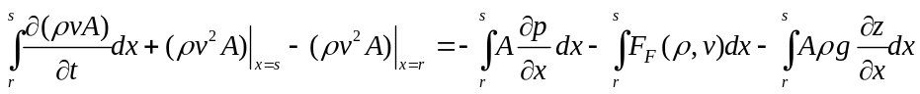
and introducing appropriate mean values gives:
with 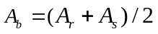. Substitution by 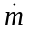 and the values at the respective boundaries and introducing 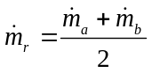 gives
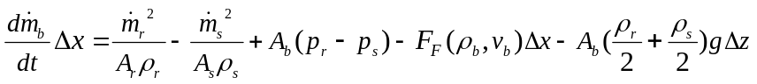
The corresponding Modelica code is:

der(m_dot(b))*dx =
m_dot_middle(r)^2/(A(r)*d(r)) - m_dot_middle(s)^2/(A(s)*d(s))
+ A(b)*(p(r) - p(s)) - F_F(b)*dx
- A(b)*(d(r)/2 + d(s)/2)*g*(Z_b - Z_a);

This momentum balance refer to quantities in two volumes. In order to make a Modelica model for each volume, the momentum balance can be split up in two parts by using two integrals. For the right part of the volume, from r to b, we get:

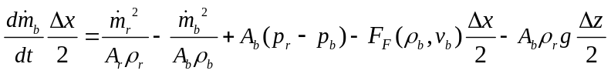
.
For the left part of the next volume, from b to s, we get:

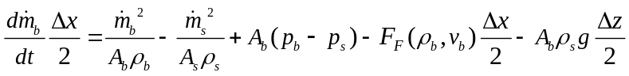
Adding these half momentum balances gives the same total momentum balance since the 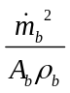 cancels.
Shifting the second momentum balance to the left volume segment from a to r gives.

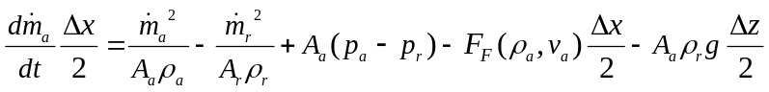

By this derivation, we have arrived at a complete model of one volume having one mass, one energy and two momentum balances.

m_dot_middle = (port_a.m_dot - port_b.m_dot)/2
"since assumed same density in entire interval a to b";

// Momentum balance over interval a to a+dx/2
der(port_a.m_dot)*dx/2 = A_m*(port_a.p - medium.p) - dp_a/2
+ port_a.m_dot^2/(A_a*medium_a.d)-m_dot_middle^2/(A_m*medium.d)
- A_m*medium.d/2*g*(Z_b - Z_a);

// Momentum balance over interval a+dx/2 to b
der(-port_b.m_dot)*dx/2 = A_m*(medium.p - port_b.p) - dp_b/2
+ m_dot_middle^2/(A_m*medium.d) - port_b.m_dot^2/(A_b*medium_b.d)
- A_m*medium.d/2*g*(Z_b - Z_a;

Index reduction will be utilized and a right momentum balance and the left momentum balance of the next volume will be combined into a non-linear system of equations. Subtracting the balances gives (consider small 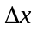and 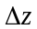for simplicity)

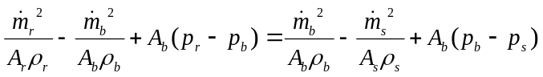

Together with the medium property at b, 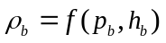, there are two equations for solving 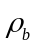 and 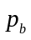. The structure of the momentum balance is
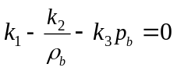
For linear pressure-density dependency, we get a second order equation which have two or none solutions. For a shock wave, there are large differences in mass flow rate at r and s and indeed, there are cases of no solution. It demonstrates that something is physically inconsistent in the model equations. We have assumed that density is constant in each volume. However, we are trying to solve for , i.e. the density at the volume boundary in order to get the velocity at the boundary. It is a contradiction of the constant density assumption. One idea would be to use a mean density instead. However, this is not possible to calculate in a model for one volume. Another possibility would be to remove the term from the momentum balances since it cancels when adding them in the case of only two volumes connected at one point. It would give the same solution for all variables except for the pressure at the volume boundary. This pressure is only used for one purpose: to calculate the temperature at the volume boundary which is used for the thermal diffusion term which is only important at low mass flow rates.

Artificial viscosity
Special considerations are needed to handle shock waves. One method is to introduce conditional artificial viscosity. Including a viscous term in the total momentum balance gives:

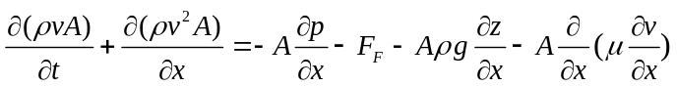
Integrating from r to s gives:
The viscosity term can be split up to the two momentum balances as follow. For the right part of the volume, from r to b, we get:

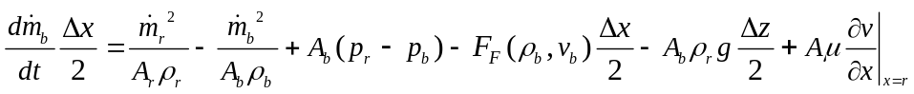

For the left part of the next volume, from b to s, we get:

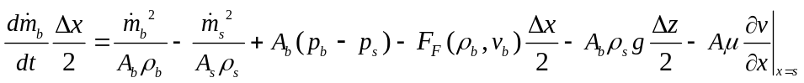

A first order approximation of the spatial derivative gives:
The second momentum balance is shifted to the current volume.

To be included:
- Conditional artificial viscosity term
- thermal conductance

Modelica model
The Modelica model equations corresponding to the mass- momentum and energy balances derived above are given below. In addition, media components are used. The semiLinear function is used to handle the interfacing of the balance volume boundary quantities with the quantities of the device. [ELABORATE]
model ShortVolume
…
end ShortVolume;

Appendix – Energy balance
This appendix contains the derivation of the equivalent but simpler energy balance.
Multiplication of the momentum balance by v gives
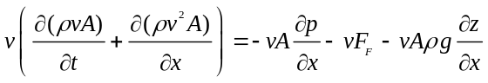
Utilizing the mass balance, this equation can be rewritten as
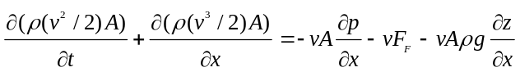
To show the equivalence, consider the two left hand sides:
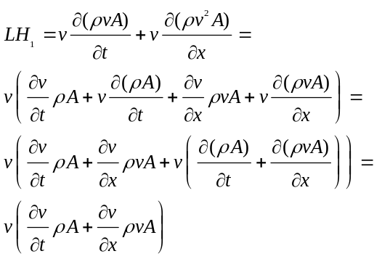

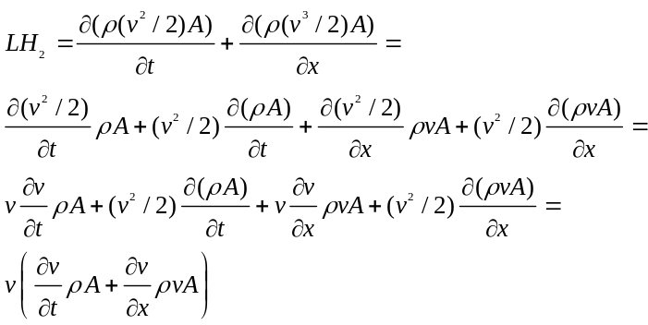
i.e. 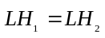.
Subtracting the equation derived above from the energy balance gives
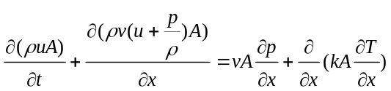

Bibliography
[TO BE UPDATED]

- Andersson J.D., Jr. (1995): Computational Fluid Dynamics – The Basics with Applications, McGraw-Hill International Editions, ISBN 0 07 001685 2.
- Colebrook F. (1939): Turbulent flow in pipes with particular reference to the transition region between the smooth and rough pipe laws. J. Inst. Civ. Eng. no. 4, pp. 14-25.
- Dymola (2003): Dymola Users Guide, Version 5.1. Dynasim AB, http://www.dynasim.se/
- Elmqvist, H. (1978): A Structured Model Language for Large Continous Systems. PhD-Thesis, Lund Institute of Technology, Lund, Sweden.
- Hilding Elmqvist, Hubertus Tummescheit and Martin Otter (2003), Dynasim, Sweden; UTRC, USA; DLR, Germany: Object-Oriented Modeling of Thermo-Fluid Systems, 3rd International Modelica Conference, Proceedings, pp. 269-286.
- Idelchik I.E. (1994): Handbook of Hydraulic Resistance. 3rd edition, Begell House, ISBN 0-8493-9908-4
- IAPWS (1997); Release on the IAPWS Industrial Formulation 1997 for the Thermodynamic Properties of Water and Steam. The International Association for the Properties of Water and Steam.
- Mattsson S.E.; Söderlind G. (1993): Index reduction in differential-algebraic equations using dummy derivatives. SIAM Journal of Scientific and Statistical Computing, Vol. 14 pp. 677-692, 1993.
- Mattsson S.E., Olsson H., Elmqvist H. (2000): Dynamic Selection of States in Dymola. Modelica Workshop 2000 Proceedings, pp. 61-67, http://www.modelica.org/workshop2000/proceedings/Mattsson.pdf
- McBride B.J., Zehe M.J., and Gordon S. (2002): NASA Glenn Coefficients for Calculating Thermodynamic Properties of Individual Species. NASA report TP-2002-211556
- Miller D.S. (1990): Internal flow systems. 2nd edition. Cranfield:BHRA(Information Services).
- Newman C.E., Batteh J.J., Tiller M. (2002): Spark-Ignited-Engine Cylce Simulation in Modelica. 2nd International Modelica Conference, Proceedings, pp. 133-142.
- Pantelides C. (1988): The Consistent Initialization of Differential-Algebraic Systems. SIAM Journal of Scientific and Statistical Computing, pp. 213-231.
- Rüdiger Franke (2003): On-line Optimization of Drum Boiler Startup. Proceedings of the 3rd International Modelica Conference, Linköping, 2003
- Span R. (2000): Multiparameter Equations of State – An Accurate Source of Thermodynamic Property Data, Springer-Verlag.
- Swamee P.K., Jain A.K. (1976): Explicit equations for pipe-flow problems. Proc. ASCE, J.Hydraul. Div., 102 (HY5), pp. 657-664.
- Thomas P. (1999): Simulation of Industrial Processes – For Control Engineers, Butterworth, Heinemann, ISBN 0 7506 4161 4.
- Tummescheit H. (2002): Design and Implementation of Object-Oriented Libraries using Modelica, PhD thesis, Department of Automatic Control, Lund Institute of Technology.
- Tummescheit H., Eborn J. (2001): ThermoFluid Modelica Library. Homepage: http://www.control.lth.se/~hubertus/ThermoFluid/

